Quarter 3A: Roman Art
Dialectic
As conquest expanded the bounds of Roman rule throughout the world, Rome’s contact with Greek art began to influence’s its artistic tradition. Romans collected Greek antiquities and blended its style with their own native Etruscan heritage. As you look at this sculpture of Julius Caesar’s adopted son (and grand-nephew), see how many similarities you can spot. What do Greek and Roman art have in common?
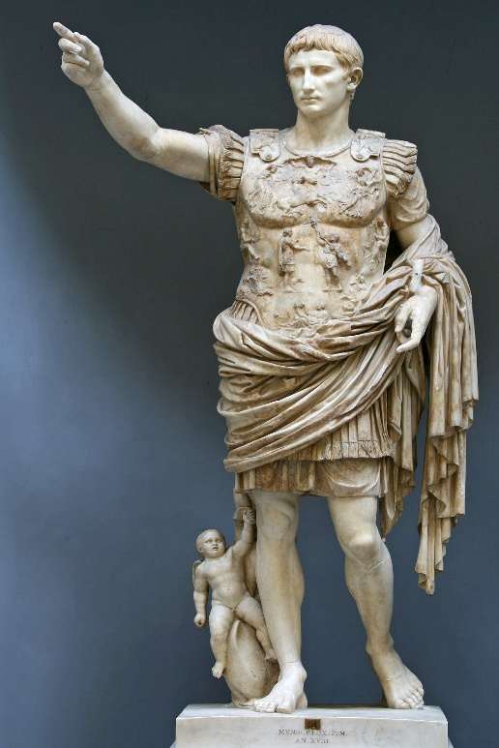
Augustus (Octavian) as general, copy of a bronze from 20 BC, marble, 6’8” high
This sculpture portrays a strong leader with his arm raised to command his troops. Although his armies facilitated the Pax Romana that secured Rome’s conquests, Octavian needed his official portrait to convince the Romans that his youth was an asset in a society that valued the wisdom of old age. He is muscular and youthful while being perfectly proportioned and balanced. The great care with which his body is depicted will remind us of the careful drawing on Greek red figure vases that outlined every muscle and facial expression with great precision. The folds of the cloth are flowing and soft while the breastplate looks like it is made of finely hammered metal. This intensely realistic sculpture reminds us of the sculptures adorning the Parthenon.
You have already studied the importance of the arch in Roman architecture; it was an important architectural innovation that allowed taller buildings to be built and it is an iconic feature of Roman art. Often, large prominent arches were constructed to honor Emperors and commemorate military victories, such as the Arch of Titus in Rome. This heavy, imposing, tribute to Titus was commissioned after his death as a monument not only to him, but also to testify to the strength of Roman empire as a whole.

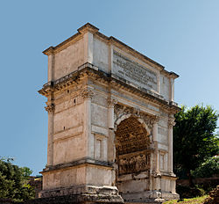
Arch of Titus, Rome, 82 AD
Inside the arch is a frieze of Roman soldiers carrying away the treasures of the Jewish temple in Jerusalem after its destruction in 70 AD. If you look closely you can see the menorah and golden trumpets being carried away. What was for the Jewish people an intensely sad event was shown in vivid detail in order to demonstrate Rome’s ability to conquer other cultures and people.
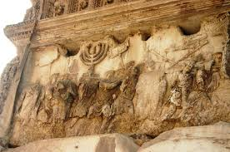
Arch of Titus (detail on inside of arch) “Spoils of Jerusalem”, 82 AD
The realism of Roman art was not confined to imperial art. It is evident in the trompe l’oeil frescoes of Roman villas uncovered in Pompeii and even in funeral portraits made in honor of beloved relatives. Many portraits painted on wooden panels have been discovered in Egypt from the time of the Roman conquest of Egypt in 30 BC. These paintings were attached to mummies as a kind of homage to the dead and although the practice of attaching portraits to mummies was well established in Egypt, these so-called Faiyum portraits employed a very Roman style of painting. The figures look directly out at the viewer. Their features are carefully drawn and no two are alike; each strand of hair is drawn and the skin is modeled with layers of paint so that it looks like real. This is the beginning of what we recognize as portraiture.
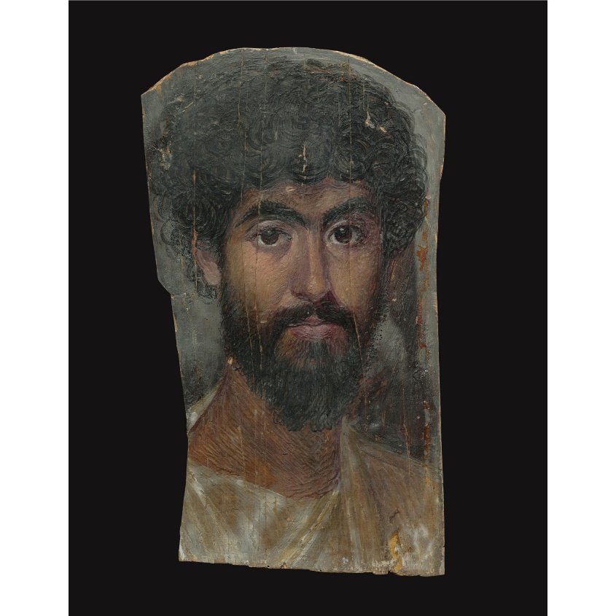
Faiyum Mummy Portrait, Egypt (under Roman rule) 170 AD
The legacy of Roman art, just as that of Greek art, is far reaching. You will recognize its influence throughout the history of art if you look carefully.

Rhetoric
Compare the Arch of Titus to the Colosseum
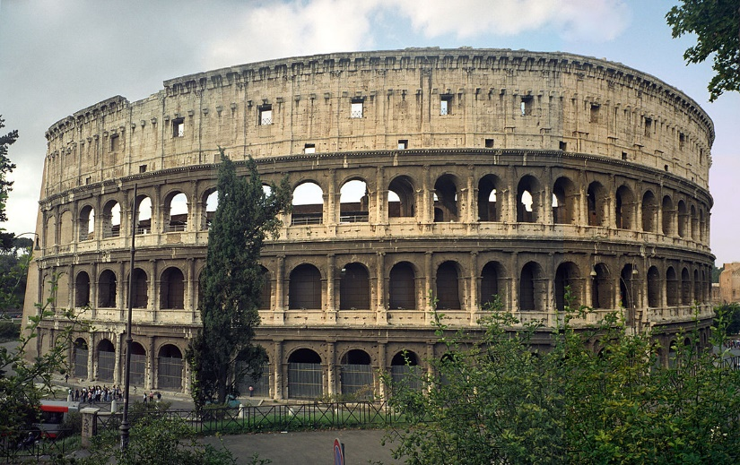
Roman Colosseum, 70 AD Arch of Titus, 82 AD
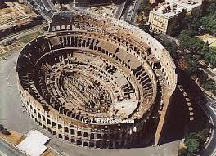
These both…
use the Roman arch, a semicircular structure that supports the weight above it and allows for an decorative open space
are monumental structures made of stone
are large, public structures that serve civic functions
are located in an urban setting, in the heart of the city of Rome. Even in ancient times they were located in a populated space.
are grand, imposing structures that only a wealthy government could afford to build
In contrast:
They had different functions. The Colosseum was built for large gatherings of people; it is a huge structure similar to a sports stadium. It housed gladiatorial fights, contests and spectacles. Many people believe that it was the place of martyrdom for many early Christians. The Arch of Titus was built to honor the memory of the emperor, who was thought by the Romans to turn into a god after death. The arch was supposed to increase Romans’ pride in the strength of their government. It existed simply to advertise Rome’s greatness.
The main decoration of the Colosseum is architectural, whereas the arch is decorated with elaborate elaborate friezes on the inside, winged victory figures on the spandrels, and columns.

Compare a Roman portrait to the Pantocrater icon: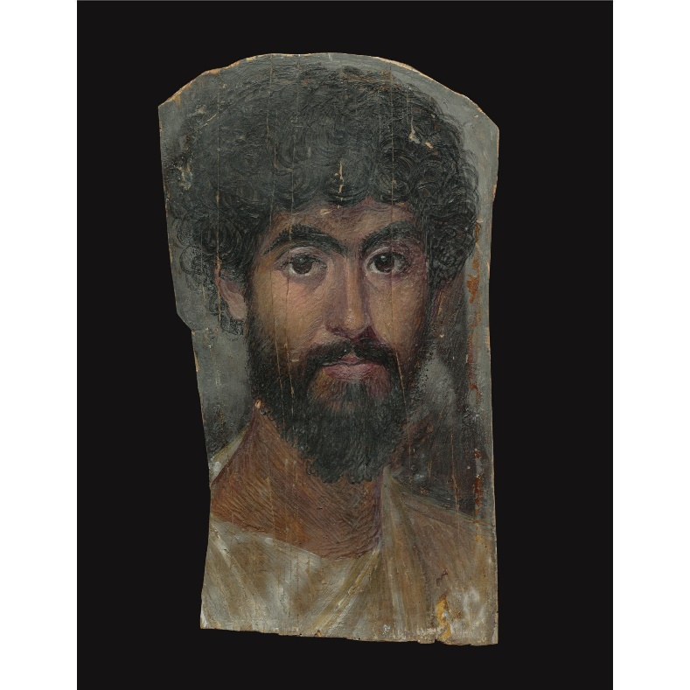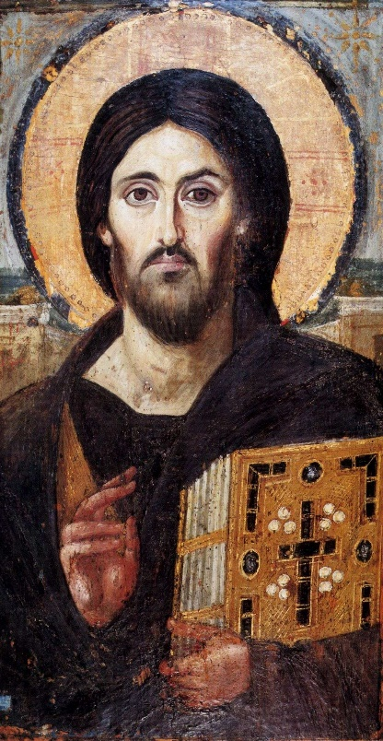
Faiyum Mummy Portrait, Egypt (Roman) Pantocrater icon, 6th C AD
Both:
depict a man staring out at the viewer with an unflinching gaze
share a similar facial type with dark eyes, a strong nose, beard and mustache
are painted with encaustic, a waxy paint that gives skin tones look especially real
are painted on wooden panels
use similar techniques for painting drapery, including using shadow to show depth
were made in homage to a beloved person, to honor his memory
give you a strong sense that you are looking at a real person

In contrast:
The portrait is of a Roman citizen, whereas the icon depicts Christ, identifiable by the golden cruciform halo and the book of Gospels (the Word of God is holding the word of God)
The portrait was meant to be buried, while the image of Christ was made to be venerated
The icon uses Christian symbolism: the cross, the book (the Gospels – it looks like contemporary manuscripts of Scripture and it is adorned with jewels), and Christ’s hand is in the position used for blessing.
Christ’s face is not as realistic as that of the portrait. If you look carefully you will see that each half of his face is quite different from the other; one half is darker, the eyes are shaped differently, and the shape of the face is slightly different. This symbolizes the human and divine natures of Christ.

