The Lepanto Herald
A Journal of Catholic Schoolhouse Co-op, Green Bay, WI
$1.50

December 8, 2016

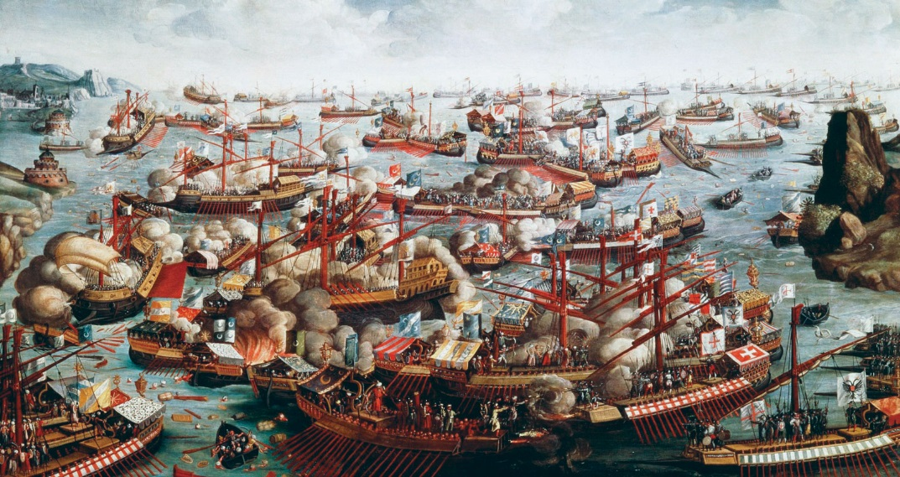
Holy League defeats Muslims at Lepanto
The Lepanto Challenge

Green Bay: On Oct. 7, 2016, the Feast of Our Lady of the Rosary, Dr. Hendrickson stirred the students of Catholica Schoolhouse with his stunning recitation of G.K. Chesterton’s Lepanto in commemoration of the battle. As a result the dialectic teacher, Mrs. Beth Mortensen, presented to her class a challenge: to memorize the approximately 144-line poem, and recite it at the end of the year performance.
See Challenge, Page 2
Inside

- Queen Isabella of Spain
- St. Teresa of Avila
- Our Lady of Guadalupe
- Interview with Kassia Lubinski
Miracle at Lepanto
Bay of Lepanto, Greece - On Oct. 7, 1571, the Muslims attacked the Christian fleet called the Holy League. The Holy League was led by Don John of Austria, while the Muslim fleet was led by Ali Pasha. Just before the battle, the wind, which was behind Muslim sails, turned 180 degrees to be behind the Holy League’s sails.
Don John, though greatly outnumbered, had enhanced his ships. He had removed from his ships all the spars, which are devices used to ram enemy vessels, in order to prevent interference with the cannons, which were on the front and back of most ships those days.
He also had six huge ships called galleas, which had cannons on all four sides and soldiers with arquebusiers, an early type of musket.
Don John and the Holy League charged the Turks. As the two sides collided smoke billowed from the cannons. He ordered his flag ship, the Ciudad Real, to charge the Turk’s flagship, the Sultana. Just before they hit, Don John yelled and burst into a dance, so excited was he.
See Miracle, Page 2
The Muslims were trying to get control of Europe, so the Muslims and the Christians went to war. King Philip of Spain sent his half-brother Don Juan of Austria to fight in his place. In Rome, the Pope prayed, “O God, will you please give us victory over the Muslims?” The Christians won with the help of Mary. The feast of Our Lady of the Rosary is October 7th. Our Lady of the Rosary, pray for us! Kassia Lubinski
Queen Isabella of Spain

Queen Isabella of Spain was born in April 1451, and she died in November 1506. The beautiful and talented Isabell was the sister of the king of Castile. She married Prince Ferdinand, the son of the king of Aragon. Their marriage joined Castile and Aragon and united Spain. One of the finest people ever to rule, Queen Isabella was a woman of incredible courage and determination. She was perhaps the greatest woman ever to sit upon any throne. She was a very devoted Catholic. Most of the important decisions and great actions of her life were influenced by her great desire to spread the Catholic Faith. In 1492 Isabella met with Christopher Columbus to provide the funds necessary for a voyage he was about to take. Little did she know that Columbus’ trip would result in the spread of Christianity to the New World that he would discover. Consequently, Queen Isabella took part in spreading the Catholic faith to the New World by financially and prayerfully supporting Columbus’ mission.
Bridget Stillwell
St. Teresa of Avila

Teresa was born in Spain in the year 1515. Hoping to be martyred by the Moors, Teresa ran away from home when she was seven years old. When she was twelve years old, she lost her mother. Her father put her in the care of the Augustinian nuns. Years later she joined the Carmelites. Teresa suffered body ailments and mental afflictions. Inspired by the Holy Ghost and saintly men of her time she undertook the task of reforming her Order and bringing it back to its primitive observance. St. Teresa’s last words were “After all, I die a child of the Church”. She died on Oct. 4, 1582. Her feast day is Oct. 15.
Daniel Marcks
Challenge (continued)
Mortensen promised the sum of ten dollars to any student who participated. “I decided to memorize Lepanto because it’s a poem that really speaks to my heart,” said Marietta, a 15-year-old dialectic student who is taking the challenge, “and because it is written by one of my favorite Catholic writers.” Other than Marietta, only Connor Stevens has publicly taken Mortensen up on the challenge, but who knows? By the end of the year, perhaps the whole dialectic class will be running neck-and-neck on the Lepanto challenge.
Magdalena Mortensen
Interview with Kassia

Kassia Lubinski is 12 years old born in the lovely state of Wisconsin, enjoys indoor and outdoor activities. She stated that some of her indoor hobbies are sewing, baking, and taking care of her siblings. In the interview Kassia mentioned she likes picking blackberries, ATV-ing, and skiing.
Although chess is not her favorite way to pass time, Kassia surprised the Tuesday chess club by defeating a seasoned player and Doctor Mortensen.
Damian Marcks
Our Lady of Guadalupe

Yesterday, December 26 1531, Bishop Juan de Zumarraga of Mexico City organized a great procession to celebrate the dedication of an adobe hut on the hill of Tepeyac. The hut was built to enshrine the miraculous image of the Mother of God on the tilma of the Aztec Indian Juan Diego. Two weeks ago, as Juan Diego was on his way to Mass, he saw a beautiful lady on the hill of Tepeyac, formerly the site of a pagan shrine. The Lady introduced herself as the Mother of god and said “I wish and intensely desire that in this place my sanctuary be erected so that in it I may show and make known and give all my love, my compassion, my help and my protection to the people.” When Juan Diego visited the Bishop to tell him of the Lady’s request, the Bishop sent him back to ask the Lady for a sign proving that she was indeed the Queen of Heaven. Juan Diego told the Lady of Bishop Zumarraga’s request and she instructed him to go to the top of Tepeyac Hill and pick the roses he would find growing there. Although it is the middle of winter Juan found the hill covered in Roses of Castile, which the Lady herself arranged in his tilma. But when Juan Diego opened his tilma in the Bishop's house, he found to his astonishment that imprinted upon it was an image of the beautiful Lady! News of this miraculous picture of the Lady of Guadalupe, as she has called herself, has spread like wildfire and thousands have flocked to see the tilma enshrined. Already a miraculous healing has occurred: Juan Diego’s father, Juan Bernardino, who was deathly ill at the time of the last apparition, claims that the Lady appeared to him just as she did on the tilma, and cured him immediately. All peoples living in Mexico are filled with joy, but none more than the Aztec Indians, who have finally been shown that this seemingly foreign faith is truly their own.
Marietta Mortensen

Miracle (continued)
At the end of the day, the Muslim fleet, which had a total of 205 ships, had lost all but 13 ships to sinking or capture. The Holy League lost only 17 ships. Twelve thousand Christian slaves were liberated from the Turks as well.
How could such a miracle have occurred? Pope Pius V had asked all Catholics to pray the Rosary for the Holy League. The Pope himself was praying in his chapel when at 4:00pm, the time the battle ended, he left and told all the bishops and cardinals there that “We have won”.
God had truly won the day for Don John and the Holy League.
Connor Stevens

